Placement Status of 1st Batch:

1. Mrs. Arpita A Salunke Aditya Birla Minacs
2. Mr. Akshay R Berde Aditya Birla Minacs
3. Mrs.Suvarna M Pawar Aditya Birla Minacs
4. Ms. Shraddha M Vyas Navjeevan Centre
5. Ms. Rekha J Gaikwad Bombay Teen Challenge
6. Mrs.Vidya H Chandorkar Bombay Teen Challenge
7. Mr. Shailesh M Gurav Swimming Teacher at Lower Parel
8. Mr. Suresh Om Prasad Video Shooting Work

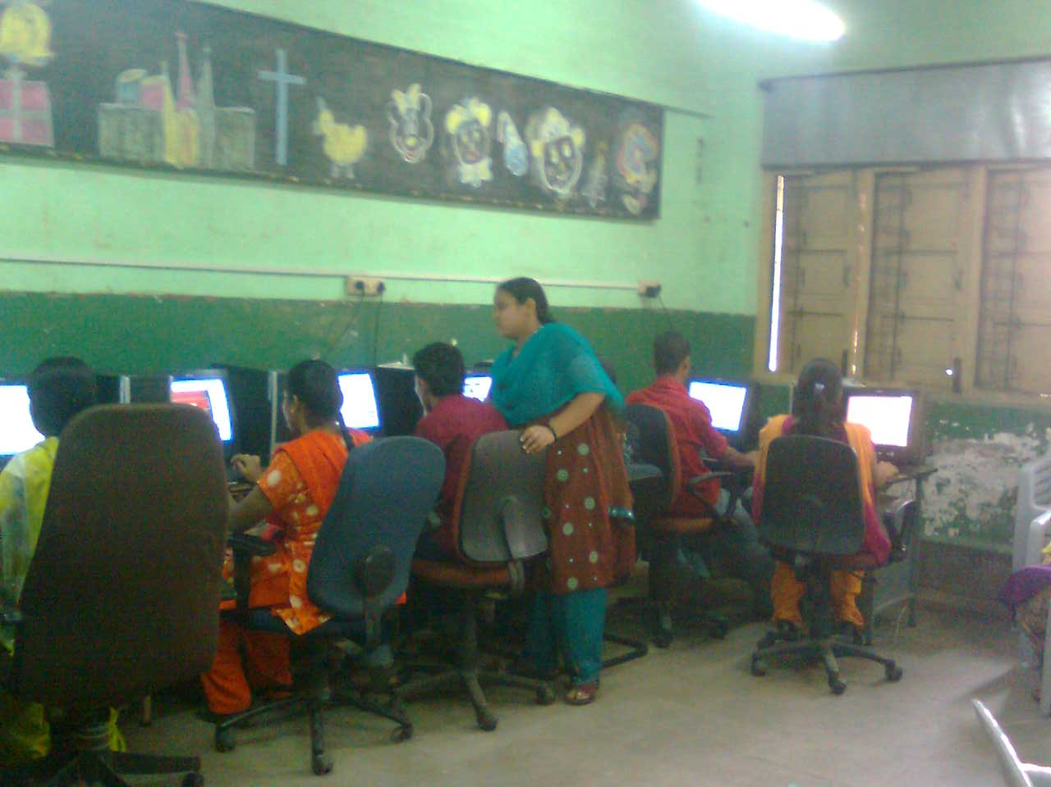
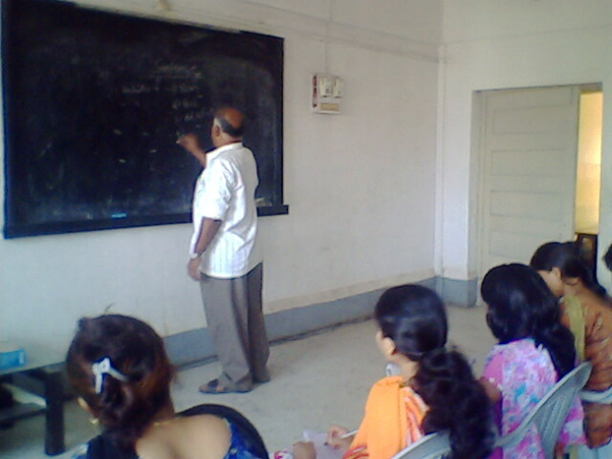
Mr. Prakash Moraye teaching Management Ms. Laxmi – Computer Instructor at Class

Placement Status:
Sr.No. | Name | Date of joining | Company | Post | Salary
1 | Ms. Sneha Gaikwad | 7/9/2009 | Dreamz Management | Tele-calling Operator | 4500
2 | Ms. Ravina Kachankar | 7/9/2009 | Dreamz Management | Tele-calling Operator | 4500
3 | Ms. Radhika Shrigadi | 7/9/2009 | Dreamz Management | Tele-calling Operator | 4500
4 | Ms. Bhavana Rathod | 7/9/2009 | Dreamz Management | Tele-calling Operator | 4500
5 | Ms. Fehmida Sheikh | 7/9/2009 | Dreamz Management | Tele-calling Operator | 4500
6 | Ms. Amrapali Katarnaware | 14/9/09 | West Side | Sales | 4800
7 | Ms. Chanchal Mishra | 14/9/09 | West Side | Sales | 4800
8 | Ms. Pramila Puralkar | 14/9/09 | Loot Store | Sales | 4200
9 | Ms. Vijaya Narayan Parab | 22/09/09 | IP INDIA COMPANY | Data entry operator | 5000
10 | Mr. Uttam Das | 21/09/09 | Café COFFEE DAY | Tr.TM | 5000
11 | Mr. Sanvidhan Katarnaware | 21/09/09 | Café COFFEE DAY | Tr.TM | 5000
12 | Mr. Ramdas Ovhal | 4/10/2009 | Asha Mahila Sanstha | Field Worker | 6500 | Promoted
13 | Mrs. Savita Pacharkar | 4/10/2009 | Asha Mahila Sanstha | Field Worker | 6500 | Promoted
14 | Ms. Sangita Kamble | 4/10/2009 | Asha Mahila Sanstha | Field Worker | 6500 | Promoted
15 | Ms. Anita Baban Jadhav | 1/11/2009 | BPL Mobile | Tele-calling Operator | 4000

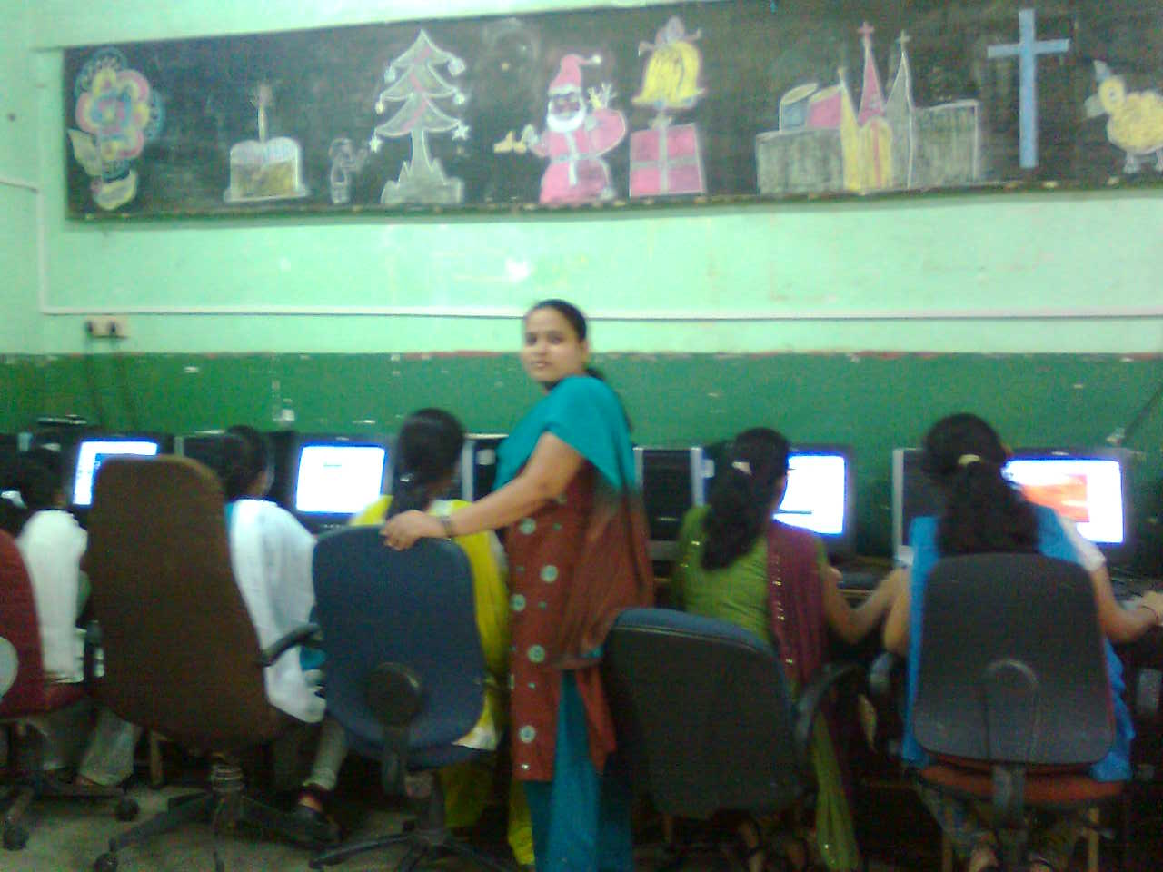
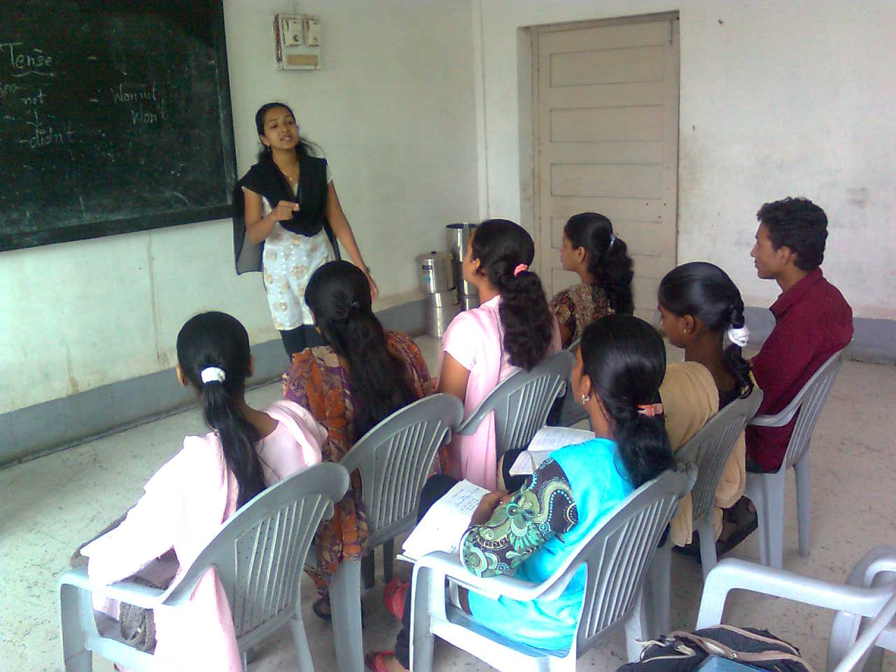
Ms. Laxmi – Computer Instructor at Class Ms. Anupama Chorge – English Teacher at Class

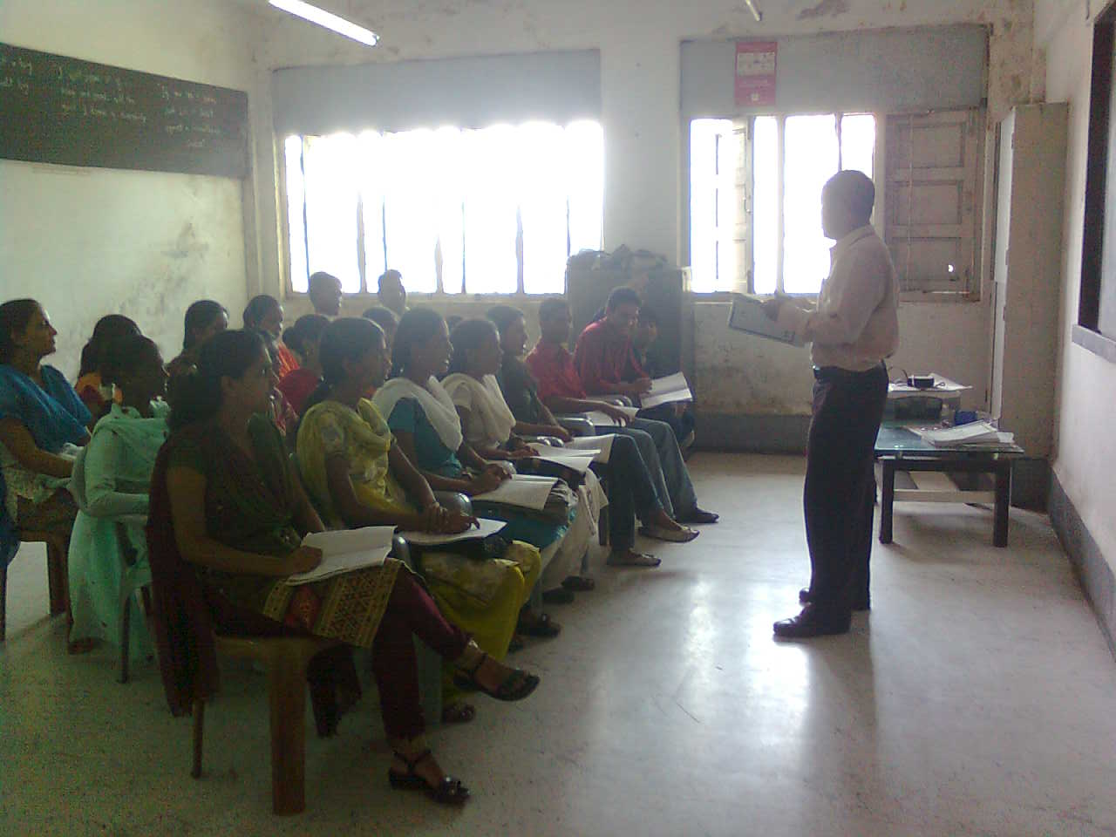
Figure 1 Mr. Sushil Bhatkar - Management Teacher at Class

Case Study: 1st Batch (Feb 2009 to May 2009)

- NAME : Ms. Rekha Jayram Gaikwad

  - AGE: 22 Years

  - QUALIFICATION: S.S.C Passed

  - COURSE DURATION: 1ST Feb 2009 to 31ST May 2009

  - PLACEMENT: Placed individually at Bombay Teen Challenge (NGO)

  - BENEFITS OF THE COURSE: Got promoted in the job as Teacher cum caretaker. Knowledge of Computer and English benefited her in presently teaching the small children at their NGO center.


- NAME : Mr. Akshay Rajendra Berde

    - Age : 19 Years

    - QUALIFICATION : H.S.C Com. Passed

    - PLACEMENT : Placed in Aditya Birla Minacs

    - BENEFITS: Due to SteP Course Communication Skills got improved with self confidence.

    - COURSE DURATION : 1ST Feb 2009 to 31ST May 2009

    - JOB SATISFACTION : Due to efforts of Smile and Prayog Foundation the entire Family and the candidate himself is satisfied with the job and are really thankful providing such a great platform for securing the future.


3. NAME: Vidya Harish Chandorkar

- AGE : 22 Years.

- QUALIFICATION: S.S.C Passed

- COURSE DURATION : 1ST Feb 2009 to 31ST May 2009

- Placement: Placed Individually at Bombay Teen Challenge (NGO)

- Benefit: Completion of the course resulted in promotion in the job from Asstt. To Nurse cum In-charge. Got the confidence in managing the Office.


4. Name: Mrs. Arpita Abhishek Salunke

    - AGE :28 Years

    - QUALIFICATION : S.Y.B.COM

    - COURSE DURATION : 1ST Feb 2009 to 31ST May 2009

    - Placement : Placed in Aditya Birla Minacs

    - Benefit: Due to Step Course Communication skills got improved with self confidence.

5. NAME: Ms. Suvarna Manoj Pawar

      - AGE : 30 Years

      - Qualification: T.Y.B.A Passed

      - Course Duration: 1st Feb 2009 to 31st May 2009

      - PLACEMENT: Placed in Aditya Birla Minacs

      - Benefit: Completion of Step course resulted in good placement job.

Case Study:2nd Batch (8th June – 31st August 2009)

1.NAME : Ms. Sneha Vishwas Gaikwad.

  - AGE: 19 Years

  - QUALIFICATION: H.S.C Com.

  - COURSE DURATION: 8th June 2009 to 31ST August 2009

  - PLACEMENT: Placed at Dreamz Management.

  - POST: Tele-calling Operator.

  - SALARY : 4500/-

  - BENEFITS OF THE COURSE: Improvement in English talking,

Got a confidence, got a better knowledge of computer.

  - JOB SATISFACTION: Satisfied with job.


2. NAME : Ms. Radhika Ganesh Shrigadi

  - Age : 19 Years

  - QUALIFICATION : H.S.C Com.

  - COURSE DURATION: 8th June 2009 to 31ST August 2009

  - PLACEMENT: Placed at Dreamz Management.

  - POST: Tele-calling Operator.

  - SALARY : 4500/-

  - BENEFITS OF THE COURSE: Due to SteP Course Communication Skills got improved with self confidence.

  - JOB SATISFACTION: Satisfied with job.

- NAME: Ms. Ravina Arun Kachankar


  - AGE : 18 Years

  - QUALIFICATION: H.S.C Passed

  - COURSE DURATION : 8th June 2009 to 31ST August 2009

  - PLACEMENT: Placed at Dreamz Management.

  - POST: Tele-calling Operator.

  - SALARY : 4500/-

  - BENEFITS OF THE COURSE: My fear has reduced and I am able to talk confidently. Since we get an opportunity to learn many things.

  - JOB SATISFACTION: Satisfied with job.

4. Name: Ms. Amrapali Ambudas Kataranavre

- AGE :23 Years

- QUALIFICATION : T.Y.B.A passed

- COURSE DURATION : 8th June 2009 to 31ST August 2009

- PLACEMENT : Placed in West Side Mall

- POST: Sales

- SALARY : 4800/-

- BENEFITS OF THE COURSE: Due to Step Course Communication skills got improved with self confidence and knowledge of retail management.

- JOB SATISFACTION : Satisfied with job.

5. NAME: Ms. Chanchal Lata Mishra

  - AGE : 23 Years

  - QUALIFICATION: T.Y.B.A Passed

  - COURSE DURATION: 8th June 2009 to 31ST August 2009

  - PLACEMENT: Placed in West Side Mall

  - POST: Sales

  - SALARY : 4800/-

  - BENEFITS OF THE COURSE: Completion of Step course resulted in good placement job.

  - JOB SATISFACTION : Satisfied with job.

6. NAME: Ms. Vijaya Narayan Parab


  - AGE : 18 Years

  - QUALIFICATION: H.S.C Passed

  - COURSE DURATION: 8th June 2009 to 31ST August 2009

  - PLACEMENT: Placed in IP INDIA COMPANY

  - POST: DATA ENTRY OPERATOR

  - SALARY : 5000/-

  - BENEFITS OF THE COURSE: Completion of Step course resulted in good placement job.

  - JOB SATISFACTION : Satisfied with job.

7. NAME: Ms. Pramila Yeshwat Puralkar

  - AGE : 25 Years

  - QUALIFICATION: T.Y.B.A Passed

  - COURSE DURATION: 8th June 2009 to 31ST August 2009

  - PLACEMENT: Placed in Loot Store

  - POST: Sales

  - SALARY : 4200/-

  - BENEFITS OF THE COURSE: Completion of Step course resulted in good placement job.

  - JOB SATISFACTION : Satisfied with job.

